**Exercise 2: Create and Deploy an Unsupervised Model**

Duration: 60 minutes

In this exercise, you will create and deploy a web service that uses a pre-trained model to summarize long paragraphs of text.

**Task 1: Install libraries**

The notebook you will run depends on certain Python libraries like nltk and gensim that will need to be installed in your cluster. The following steps walk you through adding these dependencies.

1. Within the Workspace, select the Workspace item in the menu and navigate to the folder where you uploaded the Databricks Archive (which should be [your-name/AI-lab]), and select the notebook called init. This will open the notebook so you can read and execute the code it contains.
2. Read the instructions at the top of the notebook, and execute the cell. Remember you can use SHIFT + ENTER to execute the currently selected cell, and if you do not have a cluster attached, you will be prompted to attach to the cluster you recently deployed. This will create a file named init.bash that installs required libraries on the cluster.
3. From the left-hand menu in your Workspace, select **Clusters**.

[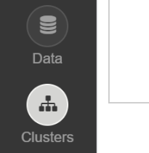](https://github.com/jumpstartninjatech/HeroSolutions-ML/blob/master/Day2/Cognitive-services-and-deep-learning/Hands-on%20lab/media/image3-4.png)

1. In the list of clusters, select your cluster.

[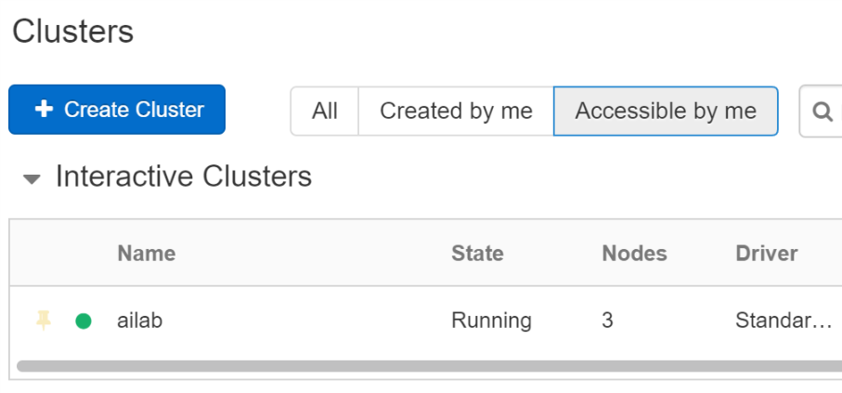](https://github.com/jumpstartninjatech/HeroSolutions-ML/blob/master/Day2/Cognitive-services-and-deep-learning/Hands-on%20lab/media/image3-5.png)

1. Select **Edit** to configure the cluster.

[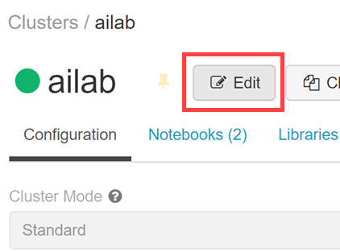](https://github.com/jumpstartninjatech/HeroSolutions-ML/blob/master/Day2/Cognitive-services-and-deep-learning/Hands-on%20lab/media/edit-cluster.png)

1. Expand **Advanced Options** at the bottom, then select **Init Scripts**. Enter the following into the Init Script Path, then select **Add**: dbfs:/databricks/scripts/init.bash

[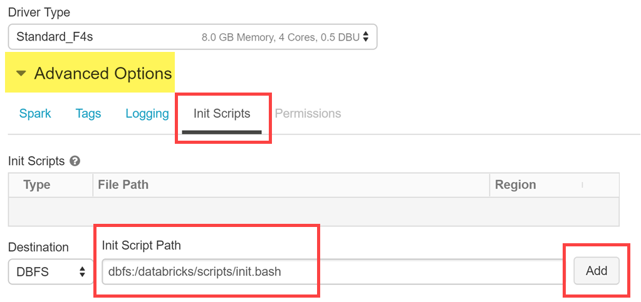](https://github.com/jumpstartninjatech/HeroSolutions-ML/blob/master/Day2/Cognitive-services-and-deep-learning/Hands-on%20lab/media/init-scripts.png)

1. Select **Confirm and Restart** after adding the Init Script Path.

[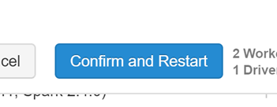](https://github.com/jumpstartninjatech/HeroSolutions-ML/blob/master/Day2/Cognitive-services-and-deep-learning/Hands-on%20lab/media/confirm-and-restart.png)

**Task 2: Read through and execute the Summarization notebook**

1. Within the Workspace, select the Workspace item in the menu and navigate to the folder where you uploaded the Databricks Archive (which should be [your-name/AI-lab]), and select the notebook called 01 Summarize. This will open the notebook so you can read and execute the code it contains.
2. Read the instructions at the top of the notebook, and execute the cells as instructed. Remember you can use SHIFT + ENTER to execute the currently selected cell, and if you do not have a cluster attached, you will be prompted to attach to the cluster you recently deployed.

**Task 3: Provision the Azure Machine Learning Workspace and Create the Summarization service**

1. From the left-hand menu in your Workspace, select **Clusters**.

[](https://github.com/jumpstartninjatech/HeroSolutions-ML/blob/master/Day2/Cognitive-services-and-deep-learning/Hands-on%20lab/media/image3-4.png)

1. In the list of clusters, select your cluster.

[](https://github.com/jumpstartninjatech/HeroSolutions-ML/blob/master/Day2/Cognitive-services-and-deep-learning/Hands-on%20lab/media/image3-5.png)

1. Select the **Libraries** tab and then select **Install New**.

[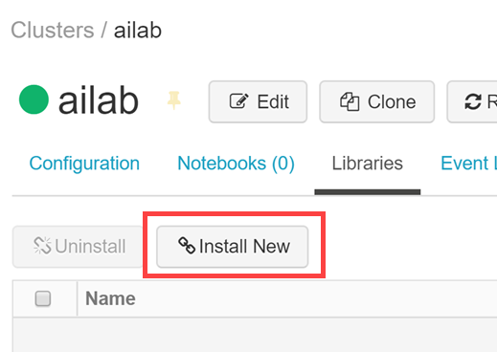](https://github.com/jumpstartninjatech/HeroSolutions-ML/blob/master/Day2/Cognitive-services-and-deep-learning/Hands-on%20lab/media/image3-6.png)

**Note**: There are interface updates being deployed, if you do not see the Install New button, instead go to the Azure Databricks menu option in your Workspace (the very top option on the left) and select Import Library. Then select a source of **Upload Python Egg or PyPi** and then provide the Package name specified in the following steps in the PyPi Name text box. Then in the Status on running clusters list, check the checkbox Attach that is listed to the left of your cluster's name to install the library on your cluster. When successful the Status should read Attached.

1. In the Library Source, select **PyPi** and in the Package text box type azureml-sdk[databricks] and select Create.

[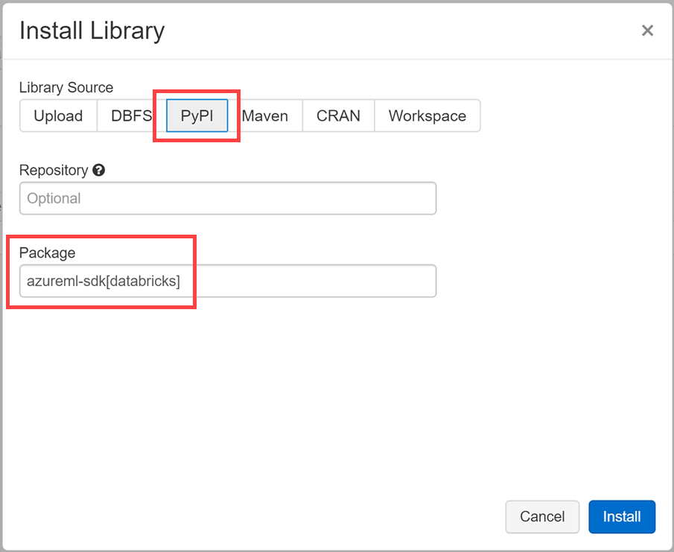](https://github.com/jumpstartninjatech/HeroSolutions-ML/blob/master/Day2/Cognitive-services-and-deep-learning/Hands-on%20lab/media/install-azureml-sdk.png)

1. An entry for azureml-sdk[databricks] will appear in the list with a status of installing followed by installed. All the other required libraries are installed through the cluster init script you added.

[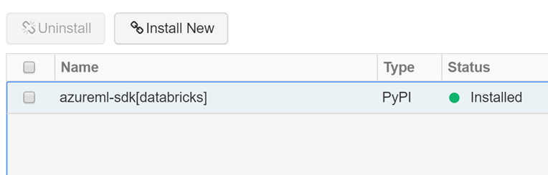](https://github.com/jumpstartninjatech/HeroSolutions-ML/blob/master/Day2/Cognitive-services-and-deep-learning/Hands-on%20lab/media/cluster-installed-library.png)

1. Within the Workspace, select the Workspace item in the menu and navigate to the folder where you uploaded the Databricks Archive (which should be [your-name/AI-lab]), and select the notebook called 02 Deploy Summarizer Web Service. This will open the notebook so you can read and execute the code it contains.
2. Read the instructions at the top of the notebook, and execute the cells as instructed. Remember you can use SHIFT + ENTER to execute the currently selected cell, and if you do not have a cluster attached, you will be prompted to attach to the cluster you recently deployed.

Pay attention to the top of the notebook where you are asked to ensure the Azure Machine Learning Python SDK(azureml-sdk[databricks]) is installed. You completed this in steps 3 and 4 above.